**S3 Bucket Lab**

1. Create an S3 bucket with the name of data bucket.

* In this bucket we have to upload the files

1. Also create an S3 bucket with the name of log bucket.

* In this bucket we can only track the activity about what time and when the file uploaded.

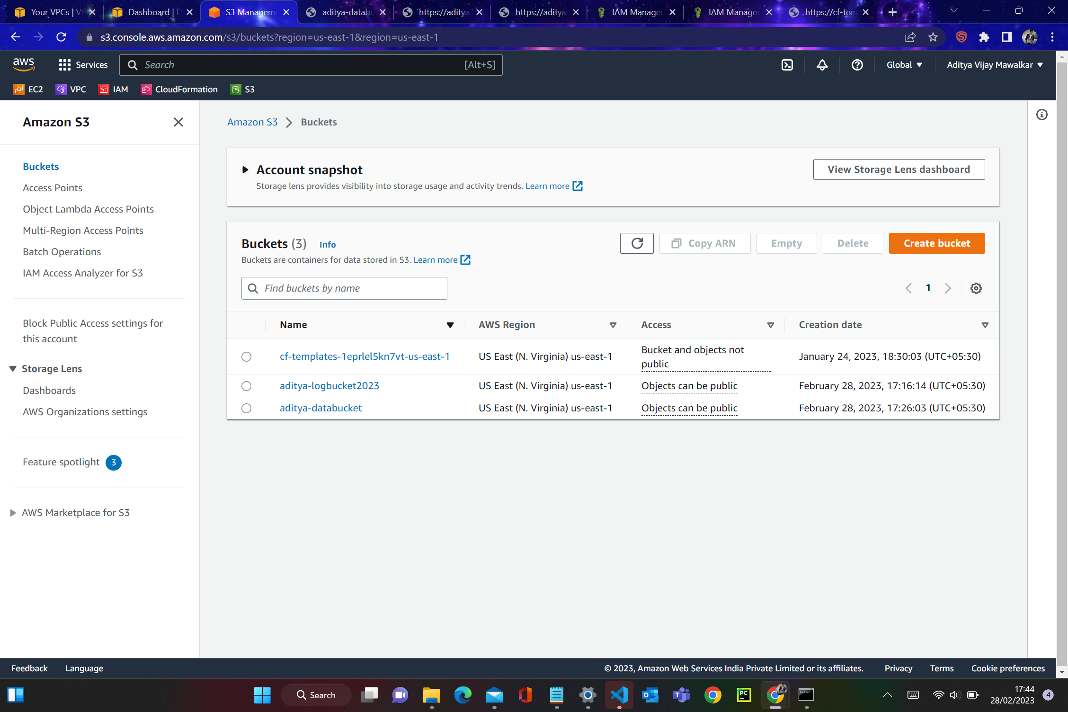

1. Then upload two different files in the data bucket.

* Index.html
* Error.html

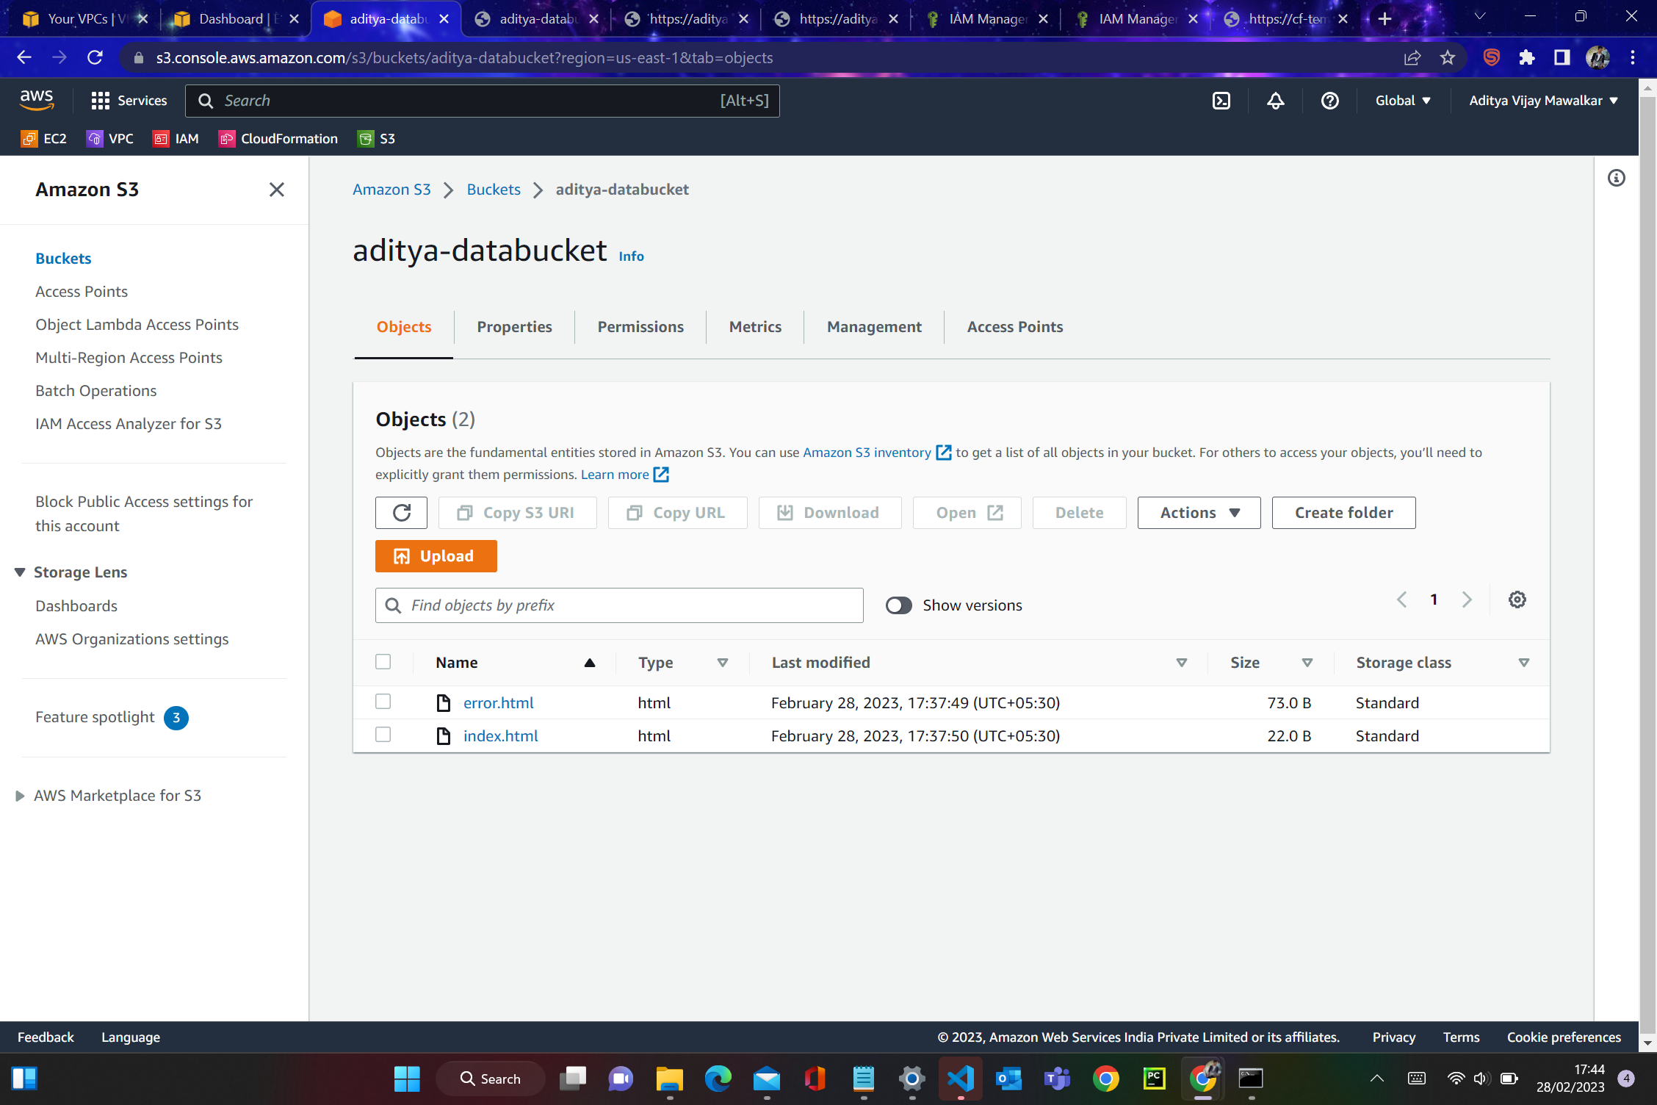

1. Then select the S3 data bucket and go to the properties.

* Enable bucket versioning
* Also enable server access logging
* Enable static website hosting

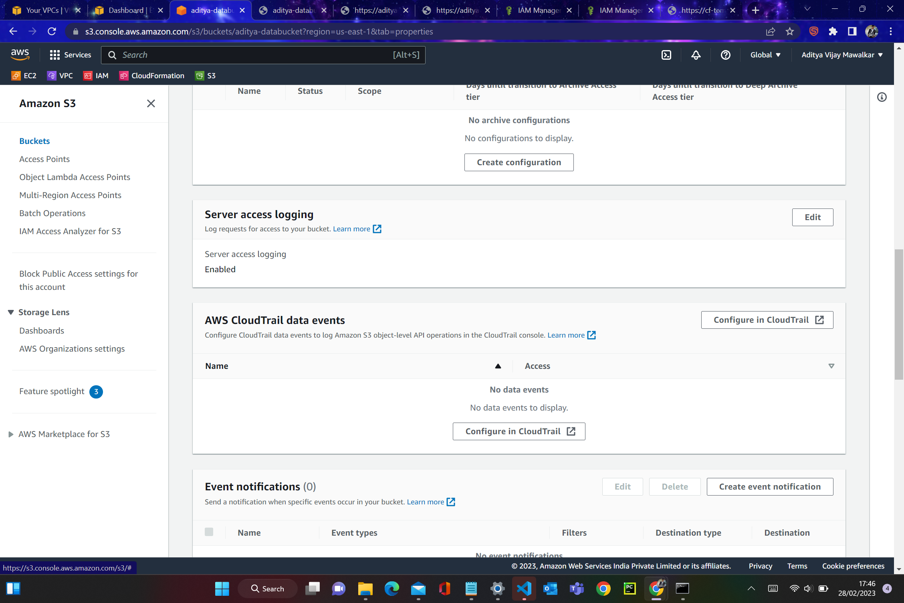

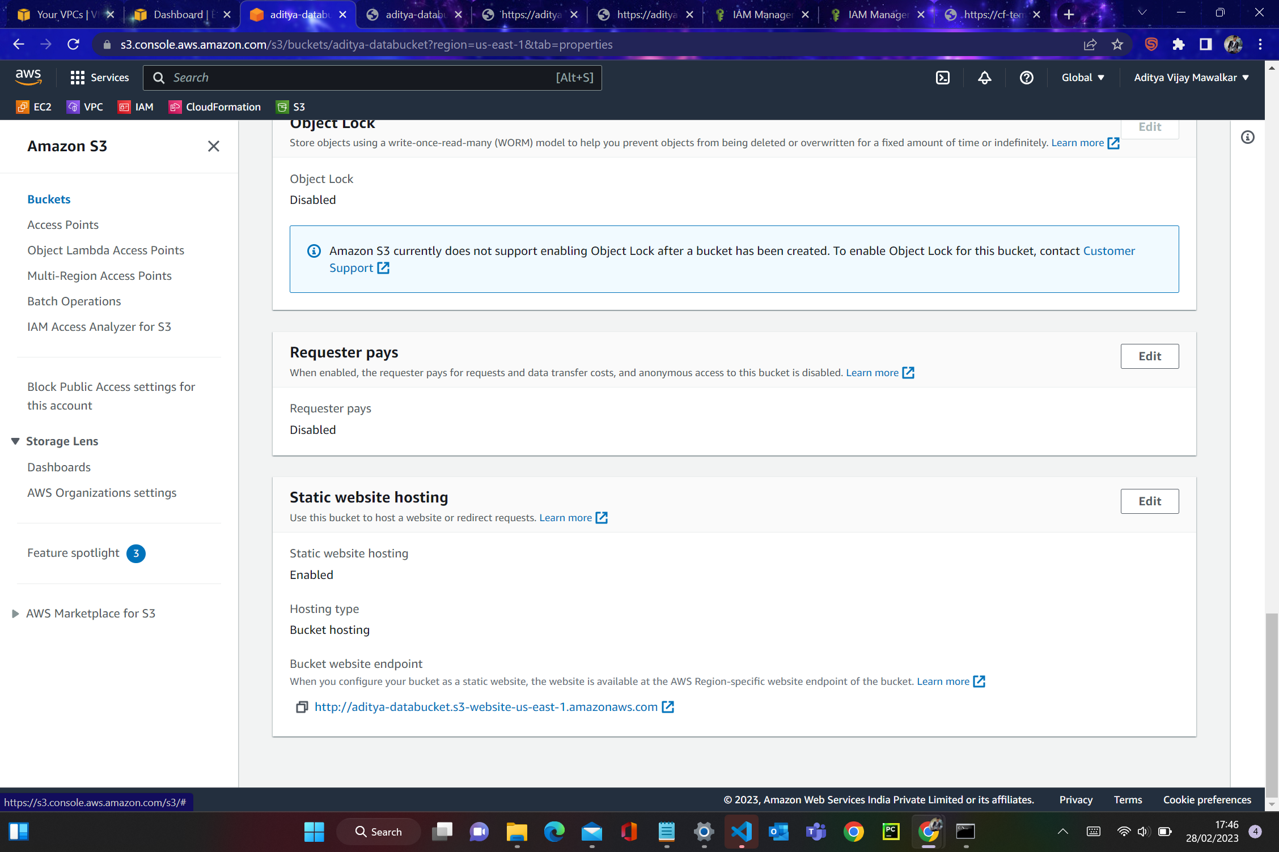

1. Then we’ll get the link in both uploaded files to see the output of those files.
2. Open the index.html link and we’ll get the output.
3. Open the error.html link and we’ll get the output.



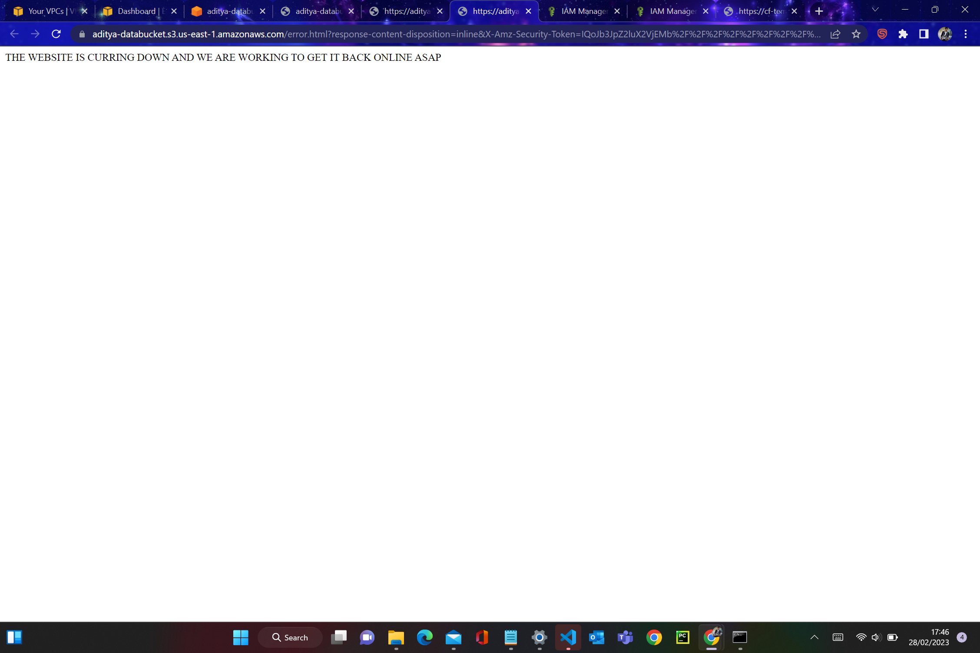

1. Now we have to change public access in the the ACL permission of index.html file.

